* Terraform fmt: The terraform fmt command is used to rewrite Terraform configuration files to a canonical format and style. This command applies a subset of the Terraform language style conventions, along with other minor adjustments for readability.
* Terraform console: This command provides an interactive command-line console for evaluating and experimenting with expressions.
* Region and AZ: Each AWS Region is a separate geographic area. Each AWS Region has multiple, isolated locations known as Availability Zones.
* Expectation  
  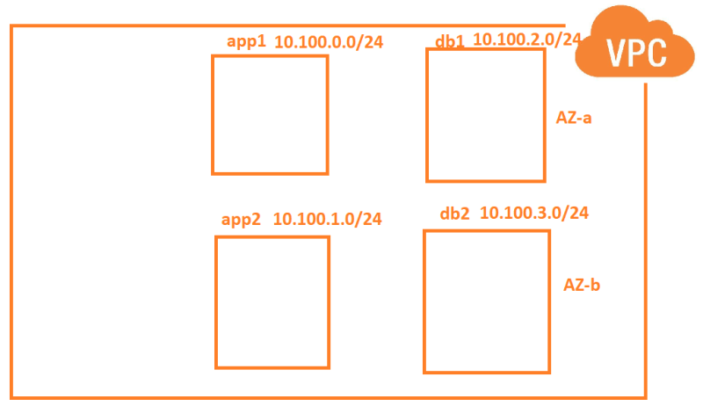
* Manual steps  
  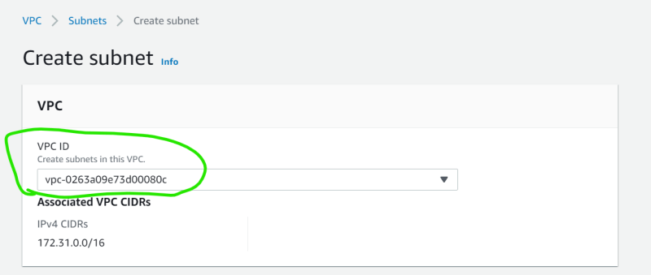  
  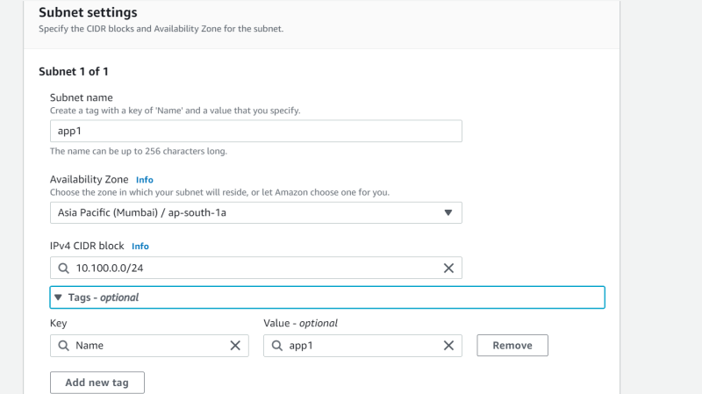
* To access outputs i.e. attributes of a resource syntax is

<resoure_type>.<name>.<atrribute-name>

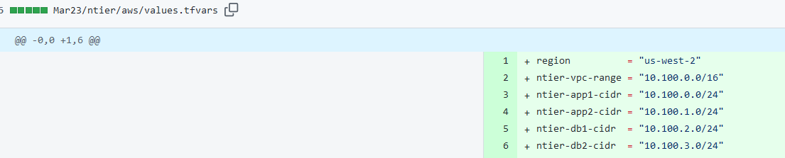

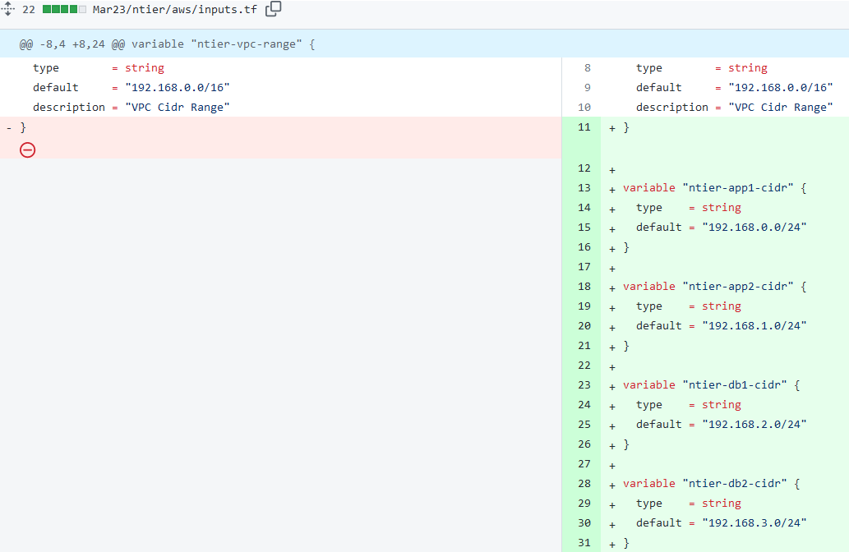

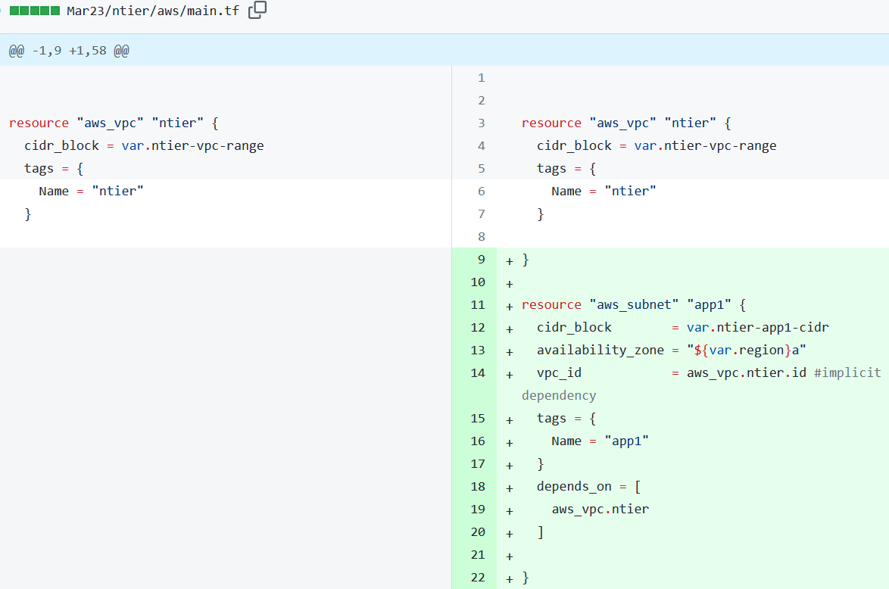

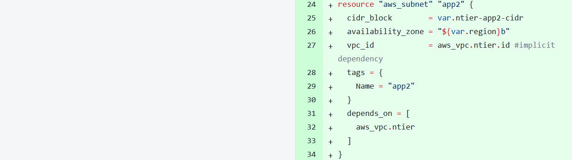

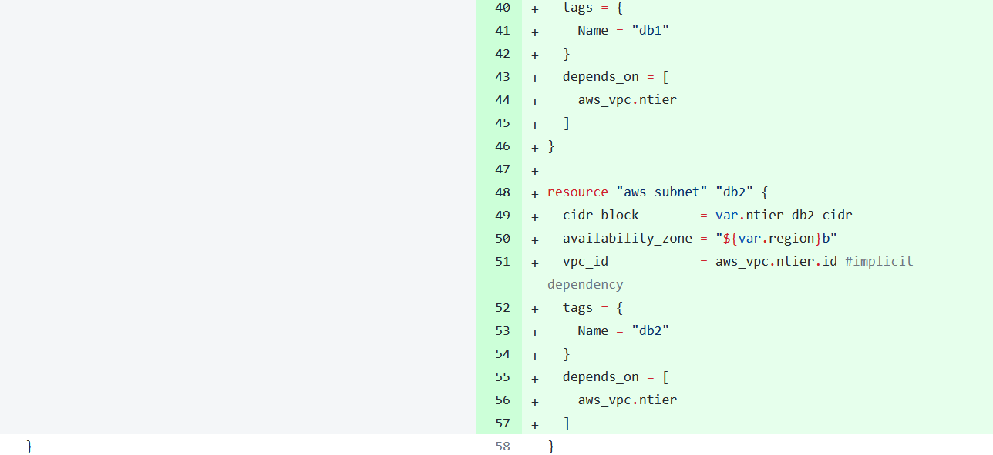

Link:<https://github.com/asquarezone/TerraformZone/commit/02832c0fdfa13de630a841d512091cea952a71d1>   
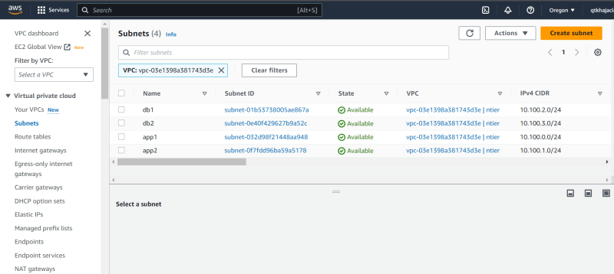

Meta argument for terraform: <https://developer.hashicorp.com/terraform/language/meta-arguments/>

Count> for creating multiple resource <https://developer.hashicorp.com/terraform/language/meta-arguments/count>

Depends on> to specify dependency <https://developer.hashicorp.com/terraform/language/meta-arguments/depends_on>

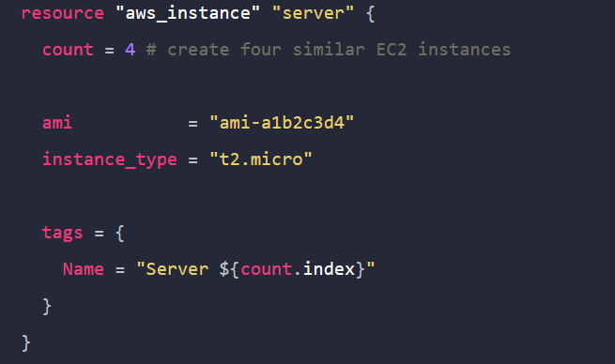

For each> when you want to run thing for all <https://developer.hashicorp.com/terraform/language/meta-arguments/for_each>

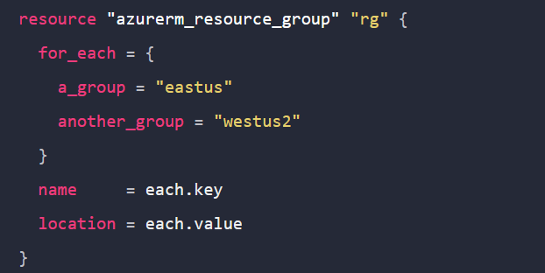

Let’s apply the count for subnet creation <https://github.com/asquarezone/TerraformZone/commit/148ceb1385c2b4f08537d4579dc2a3aa98168fbf> for changes

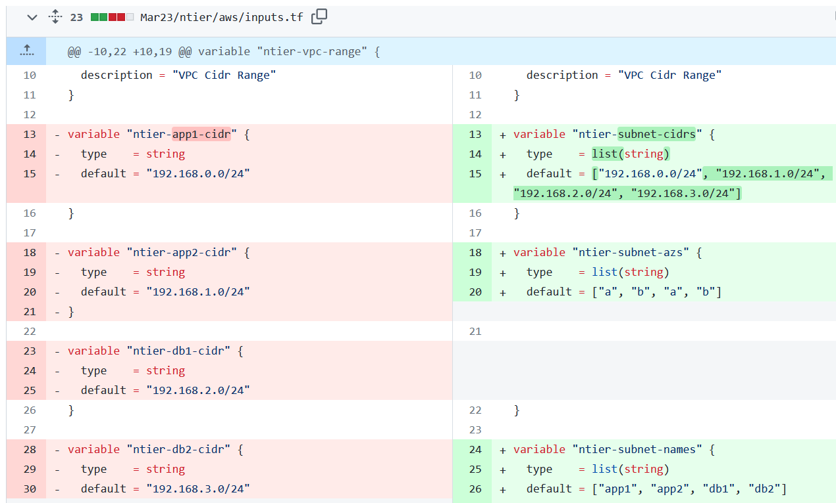

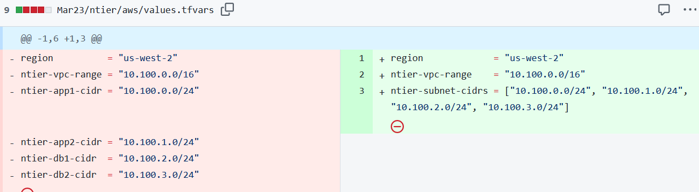

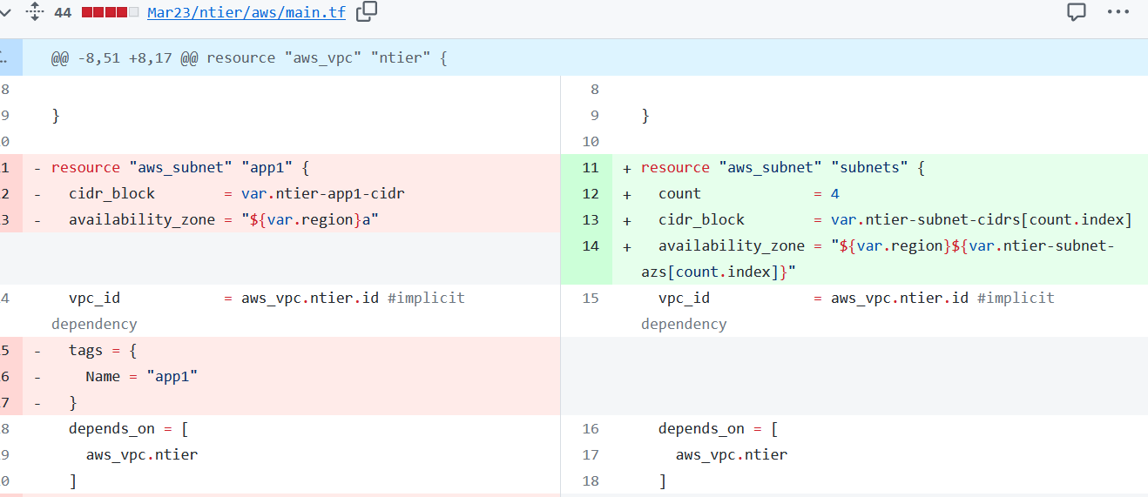

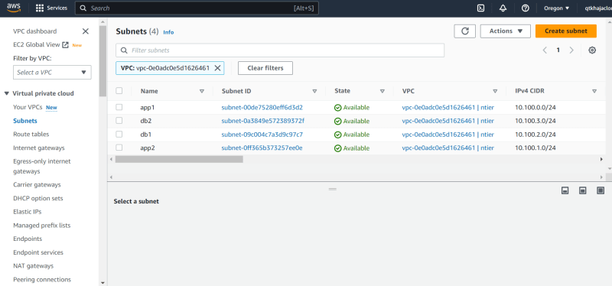

* Let’s start using terraform functions to make further improvements using terraform functions <https://developer.hashicorp.com/terraform/language/functions>
* Terraform functions: The Terraform language includes a number of built-in functions that you can call from within expressions to transform and combine values.
* Let’s replace static count of 4 with length function <https://developer.hashicorp.com/terraform/language/functions/length>
* Changeset looks like:

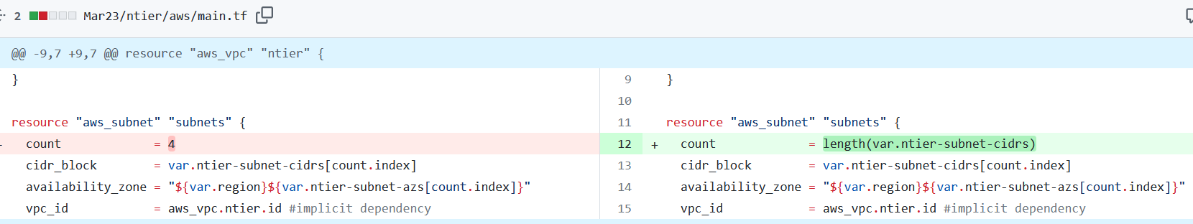

Code:<https://github.com/asquarezone/TerraformZone/commit/bc031c68f1be1291e05639df3dc544542da936e8>

Terraform plan: The terraform plan command creates an execution plan, which lets you preview the changes that Terraform plans to make to your infrastructure.